

___________________________________________________________________________

Artificial Intelligence (LAB)
Lab report 4

Submitted BY:
Fiza Mushatq
SU92-BSSEM-S25-016
BSSEM-4A

Submitted To:
Sir. Rasikh Ali

Task 01:
- First Three Expansions A* Search

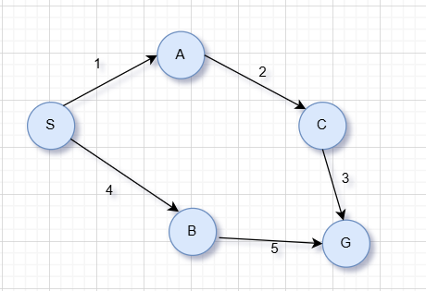
f(n) = g(n) + h(n)
Calculation of g, h and f values:
Node | g(n) | h(n) | f(n)=g(n)+h(n)
S | 0 | 5 | 0+5=5
A | 0+1=1 | 4 | 1+4=5
B | 0+4=4 | 4 | 4+4=8
C | 1+2=3 | 2 | 3+2=5
G | 3+3=6 | 0 | 6+0=6

Expansion and Frontier Details:
Expansion | Selected node | Frontier after expansion | Next node selected | Reason
1 | S(f=5) | A(f=5), B(f=8) | A | A has the lowest f value
2 | A(f=5) | C(f=5), B(f=8) | C | C has the lowest f value
3 | C(f=5) | G(f=6), B(f=8) | G | G has the lowest f value

Explanation:
A picks the node with the lowest f(n) = g(n) + h(n). when we expands S both A and B are added to our frontier we pick A first it has low value of 5. Then C is picked when we expand C, G is added to our frontier. G is choosen as it has the lowest of value 6 compared to B. the first 3 nodes expands are S, A, C. the next node is G.
Task 02:
- A* and UCS Comparison
They have the same graph start node S and goal node G. the only difference between them is that A* will use the given heuristic and UCS will use a zero heuristic.
Item | A* search | UCS
Resulting path | S->A->C->G | S->A->C->G
Total cost | 1+2+3 = 6 | 1+2+3 = 6
Nodes expanded | S, A, C, G | S, A, C, G
Numbers of nodes expanded | 3 | 4

A* used f(n) = g(n) + h(n) while UCS only used g(n). this is due to B being expanded before goal G as it has a lower path cost 4 than 6. Gis included in the list of nodes expanded but the number of nodes does not include G as there are no more expansions from G. no outdated nodes were present in this run.
Task 03:
- Overestimate Heuristic
The only thing that has changed is the heuristic values for C.
Previous: h(C) = 2
New: h(C) = 10
The true cost from C to G = 3 is 3 ( as the cost of edges between Cand G is 3) therefore h(C) = 10 is overestimated
Item | Old A | New A
Path returned | S-A-C-G | S-B-G
Cost of path | 1+2+3 = 6 | 4+5 = 9
Nodes expanded | S-A-C-G | S-A-B-G
Expansions | 3 | 3

Explanation:
As we have increased our heuristic value the path through C no longer looks like a good option. This means node A chooses to go through node B returning the paths S-B-G with a cost of 9. As our heuristic was overestimated node A no longer guarantees optimality as it may find a higher cost path. However this is not always the case and depends on the graph and run.

